Bulgarian Homeworkers in Global Supply Chains: Their
Terms and Conditions of Work

By Marlese von Broembsen and Kendra Hughes

“They are humiliating us, treating us like animals not human beings. They are behaving like owners of slaves”

“One just stops thinking [in order] to survive”.

“If you are making more than 4 Levs [2,04 Euros] per hour, they cut the rate.
So, working fast does not help.”

- Introduction

The Trade Union of Self-employed and Informal Workers (UNITY) was established in July 2014 and is a registered and recognised trade union in Bulgaria. Unity (TUSIW “Edinstvo”)’s founding member was the Association of Homeworkers in Bulgaria, which was a driving force behind Bulgaria’s ratification of Convention 177 on Homework.

The ILO Committee of Experts on the Applications of Conventions and Recommendations (CEACR) has requested the Bulgarian government to submit official research on homeworkers’ terms and conditions of work. Since UNITY is not aware of any recent official research on homeworkers, UNITY asked Women in Informal Employment, Globalising and Organising (WIEGO) to conduct this research for submission to CEACR.

WIEGO (www.wiego.org) is a twenty-year-old global research-advocacy network focused on securing livelihoods for the working poor, especially women, in the informal economy. WIEGO has a long relationship with the ILO. WIEGO is on the “ILO Special List of NGOs”, in particular because of its intense working relationship with the Statistics Department. WIEGO is the only NGO that is a member of the working group of Labour Statisticians (“Delhi Group”), that does the background work for the International Conferences of Labour Statisticians (ICLS). Other departments that WIEGO has worked with include Social Protection, WORK QUALITY, the International Standards Department (NORMES), the Research Department, COOP and ILO ACTRAV.

The paper is structured as follows: Section 2 gives a brief background to the research. Section 3 outlines the research methods. Section 4 describes the profile of the interviewees: their gender, marital status, age and length of time that they have been a homeworker. Section 5 discusses the sectors in which Bulgarian homeworkers are prevalent and the products they make. Sections 6-8 describe homeworkers’ terms and conditions of work –their piece rates, their hours of work, and the challenges they face. Section 9 concludes with recommendations offered by key people interviewed about Convention 177 and the situation of homeworkers in Bulgaria.

- Background on Bulgaria’s economy

Bulgaria’s Gross Domestic Product (GDP) has risen relatively steadily since 2009. In 2017, its GDP reached $58.815 billion (World Bank, 2018). However, the country is plagued by income inequality, poverty and social deprivation. Almost 32 per cent (31.9%) of Bulgaria’s population lives in conditions of severe material deprivation, the highest rate in the EU (European Commission, 2018). Almost 16 per cent (15.9%) of total employment in Bulgaria is informal, according to 2018 statistics from the International Labour Organization.

Bulgaria’s economy is highly integrated into global supply chains. One out of every five Bulgarians works for a firm that is part of a global supply chain (ILO 2018). The garment and footwear industries are major employers: Bulgaria’s National Statistical Institute (2018) reports that in 2017, five per cent of employees (109 465 people) across all economic sectors are employed in the textile, apparel, and leather sectors. An estimated 50 000 additional people – one third of the workforce in these sectors – are either semi-formal (their labour contracts do not reflect their real working hour or wages and they have no social security) or informal, in that they work without any contracts (Clean Clothes Campaign 2014; Ivanova et al 2014). Informal industrial outworkers, otherwise known as homeworkers, officially do not exist: they are not recorded in Bulgaria’s labour force statistics, and the factories and workshops that employ them fail to conclude written contracts and to keep official records of their employ.

- Research Methods

This research paper is based on desk research; key informant interviews; semi-structured interviews with 30 homeworkers; two focus groups with 10 homeworkers; and a three-day workshop of 20 homeworker representatives and UNITY Co-ordinators from Petrich; Pleven; Sofia; Varna; Rouse; Montana and Chirpan.

The key informant interviews took the form of open-ended meetings during 27 June to 2 July 2018. Meetings were held with Violeta Zlateva, Unity’s overall Co-ordinator; Unity’s Co-ordinator in Pleven; Georgi Trenchev, the Chairman of the Municipality of Petrich; Yanko Stoyomor, the Chairman of the budget commission in Petrich (who was previously a manager of a sewing company for 25 years); Ivan Neykov, President of Management Board of the Balkan Institute for Labour and Social Policy, Sofia; a fieldworker for Fair Wear (who needs to remain anonymous) from the town of Sandansky, where many homeworkers are; Plamen Dimitrov, President of the Confederation of Independent Trade Unions in Bulgaria (CITUB/KNSB) ; Tsvetelina Milchalieva, President of the Light Industry Trade Union Organization's Federation (FOSIL); and Anna Athansassova - Centre for Human Resource Development and Regional Initiatives in the Ministry of Labour and Social Policy (Coordinator of the Agreement between ITC and the ILO and CHRDRI).

We interviewed 30 homeworkers using semi-structured questionnaires between 29 June and 2 July and 15-18 August. All except two homeworkers come from Petrich. Most homeworkers are members of UNITY and were identified by the Petrich Co-ordinator. Others were identified by snowballing – homeworkers identifying other homeworkers. In addition, we held two focus groups with 10 homeworkers in total.

WIEGO and UNITY held a two-and-a-half-day workshop in Petrich from 15-17 August for UNITY Co-ordinators and homeworkers to prepare the report that is being submitted to the ILO on 1 September 2018 concerning the implementation of Convention 177 on Home Work. The findings of the interviews were tested with this group.

- Profile of Homeworkers Interviewed

Bulgaria’s National Statistical Institute has not published official statistics on homeworkers, which makes it is difficult to reflect the true size of the sector. However, academics such as Marshall (2010) estimate that there are over 500,000 home-based workers in the country. Most Bulgarian homeworkers (28 of the 30 interviewees) are women. In Bulgaria and in general, women comprise the vast majority of homeworkers (ILO 2013; Spooner, 2013).

Most homeworkers we interviewed (86%) are over forty-one years old and are either married (62% of interviewees) or widowed (24% of interviewees) (See Figures 1 and 2 below). The homeworkers we interviewed live in Petrich (28 interviewees), Pleven (1 interviewee), or Chirpan (1 interviewee), located in the south western, north western, and south-central regions of Bulgaria. Recent statistics from EUROSTAT (2018) confirm that the south western and south-central regions have high concentrations of “local units” involved in the manufacture of wearing apparel, textiles and leather and related products. The profile of homeworkers interviewed may be considered illustrative of the experiences of other homeworkers in Bulgaria.

Figures 1 and 2 - Age and Marital Status of Homeworkers in Bulgaria

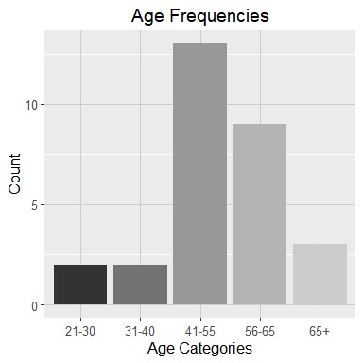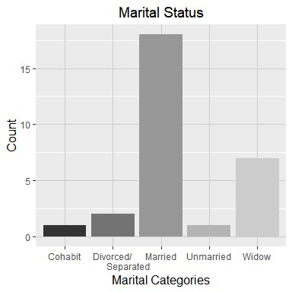

We didn’t ask homeworkers about their education levels but observed that many homeworkers were educated. For example, one woman said that prior to becoming a homeworker, she had worked as a first-grade teacher. Indeed, the vast majority of homeworkers interviewed (86.2%) have more than one income source and several have professions inside or outside the factory (see Figure 4). Income from other activities include:
- Working in a factory (10 counts)
- Pension (4)
- Disability grant/pension (3)
- Works for municipality (2)
- Sells produce, rakia or handicrafts (2)
- Cashier for TV station (1)
- Works in electrical appliances company (1)
- Medical orderly (1)
- Provides language lessons to students (1)

One-third of homeworkers work in factories. Only two of these take work from the factories in which they work. And in both these cases, the work they took home was of a different nature to the work they performed in the factory. In the one case, the homeworker was employed by a small workshop comprising 6 people and according to the homeworker, employees taking work home are paid at the same rate as they are paid for the work they do in the factory. In all other cases, factory workers took orders for work at home from factories other than their employer.

As shown in Figure 3, although there are variations in the length of time interviewees have been doing home work (ranging from 0.3 to thirty years), on average, interviewees have been homeworkers for 11.32 years (see Figure 3 below).

Figure 3 and 4 - Length of Time as a Homeworker & Income from Other Activities
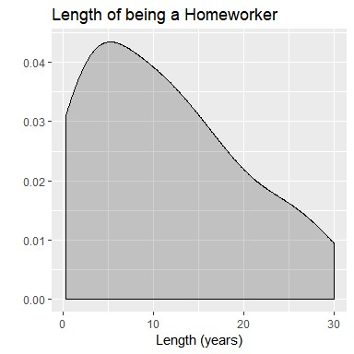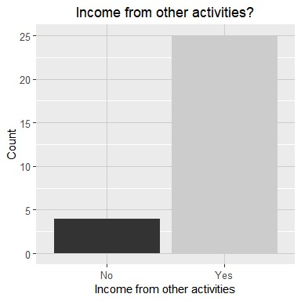

Among the 34% of homeworkers who work in factories, many commented that although their factory jobs pay the minimum wage, it is not a living wage. For reasons of economic necessity, they take on additional employment as a homeworker, a finding which is echoed by a 2014 Clean Clothes report on garment workers in Eastern Europe. An additional 27.5% of homeworkers interviewed work in a variety of other professions: for the municipality, in an electrical appliance company, as a medical orderly, as a cashier for a TV station, teaching students or selling produce or handicrafts. Both Spooner (2013) and Ivanova et al (2014) validate this finding and note that homeworkers may do seasonal agricultural work, small-scale market gardening or combine factory work with home work to subsidize their low pay. Finally, a further 24.1% of interviewees use home work to supplement their pension or disability grant. For example, a widowed homeworker reports that she packs socks for 12-15 hours a day, 7 days a week when working on a short deadline. Another widowed homeworker sews shoes for 7-8 hours a day, 7 days per week.

Homeworkers’ average household size is 2.79 people which is close to, but slightly larger than the national average of 2.3 people per household (UN, 2017). Most interviewees reported a household size of two (37.93% of respondents) or of four people (31.03%). A smaller proportion of homeworkers live in households with one, three or five people (see Table 1 below):

Table 1 - Household size of Bulgarian homeworkers
Average household size (# of members) | Distribution of households by number of members (%)
 | 1 member | 2 members | 3 members | 4 members | 5 members
2.79 | 10.34% | 37.93% | 17.24% | 31.03% | 3.45%

Over half of homeworkers (55.1%) have another working adult in their home engaged in a variety of professions/workplaces:
- factory or workshops (6 counts)
- self-employed farmers (2)
- unspecified professions (2)
- homeworker (2)
- carpenter (1)
- nurse’s aide (1)
- engineer on a construction site (1)
- national revenue agency (1)

By contrast, 41.4% of homeworkers were the sole breadwinners in their home either because they live alone, the other adult(s) was unemployed, on disability, a pensioner, or for other reasons. A notable finding is that 100% of homeworkers who were the sole breadwinners in their homes had income from other activities. Home work can therefore be considered an essential - but often insufficient - source of income to sustain workers’ households. Wages and working conditions are discussed in detail in Sections 5 to 8.

- Sectors and Products
As reflected in Figure 5, the homeworkers interviewed work in five sectors: garment; footwear; packing socks (technically part of garment); making paper bags and assembling electronic parts.

Figure 5: Homeworkers interviewed: sectors/tasks
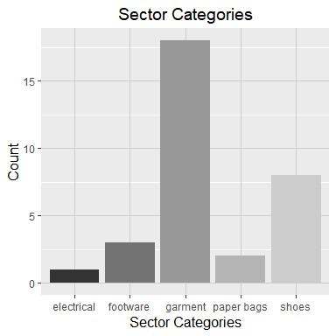
Since the majority of homeworkers - both in the sample and in general - are in the garment sector and footwear sectors, we discuss below the structure of the garment and footwear sectors. This section draws on the workshop, on the interviews, and on desk research. It aims to outline what we know, and don’t know, about how Bulgarian homeworkers are inserted into supply chains in these two sectors.

As set out in Table 2, the majority (71%) of interviewees work for one factory only. But 17 per cent receive orders from 3 factories; and two homeworkers received orders from 4 and 7 factories respectively. Both these interviewees have worked as homeworkers for over 30 years and pride themselves on their specialised skills that are sought after by the factories.

Table 2: Number of factories from which homeworkers receive orders
Number of other Factories | Count | Proportion
1 | 20 | 0.71
2 | 1 | 0.04
3 | 5 | 0.17
4 | 1 | 0.04
7 | 1 | 0.04

Apparel/Garments
Homeworkers that we interviewed often perform more than one task, particularly if they are working for more than one factory. Tasks include the following:
- Sewing buttons onto shirts (7 counts)
- Cutting the loose threads off clothing once the product has been sewn together (8)
- Gluing or sewing accessories onto T-shirts or blouses, such as beads, sequences, or chains (6)
- Sewing on labels (1)
- Using a template to trace onto a T-shirt and making applique (1)
- Sewing men’s pants together (5)
- Packing socks – putting pairs together; using a piston to tie them together; affixing a label and packaging them (5)
- Embroidery: drawing templates onto shirts and then embroidering them or embroidering “stamps” on T-shirts or scarves (4)
- Making scarves’ fringes (1)
- Sewing collars onto blouses (1)

Figure 6: Typical structures of garment supply chains
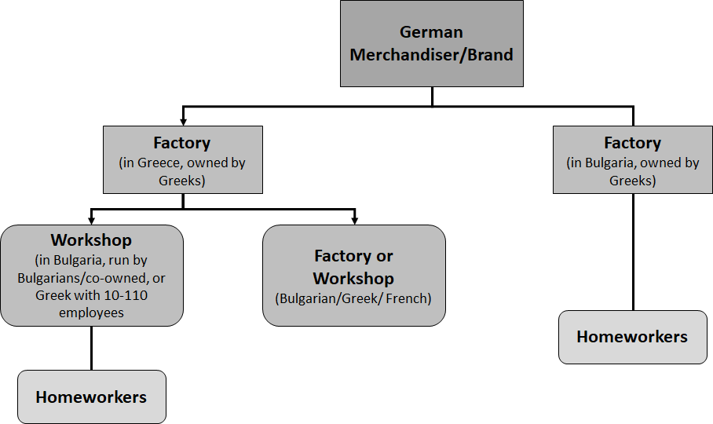
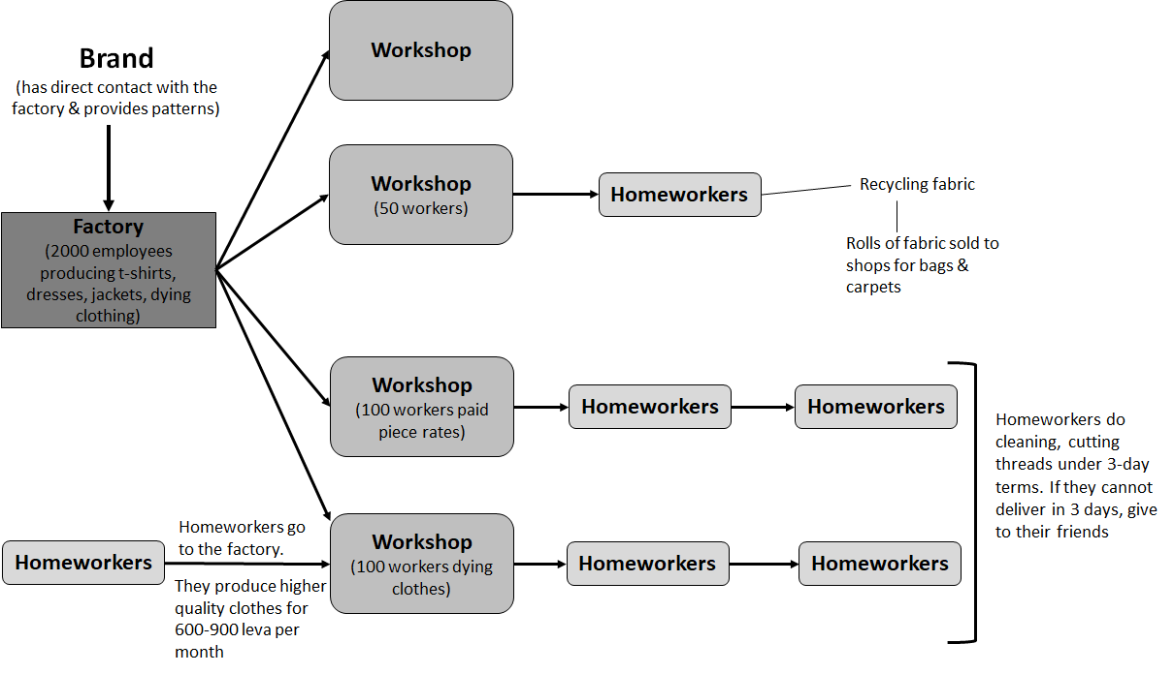

The most recent data estimate that there are 4,428 enterprises producing garments in Bulgaria (EUROSTAT (2018), most of which are concentrated in the southwest, south central and north central regions (Clean Clothes 2014). Garment production tends to be located near borders with Greece, Turkey and Macedonia to be easily accessible to buyers (Clean Clothes 2014). Although it is difficult to assess what proportion of garment and footwear factories have local, foreign ownership or joint (Bulgarian-foreign) ownership, Ivanova, Musiolek, & Luginbühl (2014) indicate that the majority (80%) of garment companies are owned by Bulgarians which are subcontracted by Turkish, Greek and Western European companies.

The World Integrated Trade Solution (WITS 2018) reports that over 60 per cent of Bulgaria’s apparel exports go to five countries: Germany, Italy, Greece, France and the United Kingdom. While many homeworkers do not know for which country their goods are destined, others do know because they work (or previously worked) in factories that give homeworkers orders; have handled the export documentation; seen packaging that shows the fabric came from Germany or elsewhere, or know the drivers who take products to other EU countries, and to Turkey.

Table 3 (below) shows the size of the factories and workshops in Bulgaria.

Table 3: Size of Enterprises Involved in “Manufacture of Wearing Apparel” (2016) in Bulgaria
 | Number of Enterprises | Share of Total Enterprises
0-9 persons employed | 3027 | 68.4%
10-19 persons employed | 447 | 10.1%
20-49 persons employed | 538 | 12.1%
50-249 persons employed | 368 | 8.3%
250 people or more | 48 | 1.1%
Total | 4428 | 100%
Source: (EUROSTAT, 2018) Annual enterprise statistics by size class for special aggregates of activities (NACE Rev.2)

Eurostat’s (2018) figures show that almost 70 percent of enterprises employ below 10 people. The next biggest category is 20-49 people (12.1 %). However, several sources (Clean Clothes, 2014; Bulgaria-European Partnership Association, 2003) suggest that official statistical figures underestimate the number of factories/enterprises, some of which may be informal. This is borne out by reports by homeworkers of workshops that seem to pop up and disappear without paying workers. In the words of one interviewee: “the employer left the country and escaped without paying. After a few months the person returns and opens a new workshop or factory. You see them in the street. The labour inspector says he cannot do anything because the company is bankrupt.” Another homeworker reported that this has happened to her four times. Key Informants confirmed this phenomenon.

Table 4: Size of factory/workshop giving homeworkers’ orders
Size of Factory (# of workers) | Count | Proportion
0-20 workers | 2 | 0.13
21-40 workers | 7 | 0.47
41-60 workers | 1 | 0.07
61-80 workers | 3 | 0.2
81+ workers | 2 | 0.13

Fifteen homeworkers knew the approximate size of the factory or workshop that gave them the work. As reflected in the figure above, almost half the homeworkers received their orders from factories that employ between 21 and 40 workers. Homeworkers receive orders from each category reflected in the above figure. Importantly, there is no significant correlation between the size of the factory and or workshop and the piece rate offered to homeworkers. If anything, smaller workshops (10 people or fewer) pay homeworkers higher piece rates than larger enterprises.

Over and over, homeworkers and key informant interviews mentioned the decline in the number of factories in Petrich and elsewhere in Bulgaria and the implications of less work available, both for factory workers and for homeworkers. According to Eurostat (2018), while the number of enterprises employing 10 or more people have declined since 2008, the number of microenterprises (employing 0-9 people) has increased (from 2,808 in 2008 to 3,027 in 2016).

Some homeworkers have seen the labels, logos or paper tags on the items, or know which brands the factory/workshop regularly produces for. All interviewees were fearful of losing their work and only disclosed the brands on condition that we did not disclose these details in the research paper. We know, however, that the following brands produce in Bulgaria, and several of these were mentioned by homeworkers:

- Inditex, H&M and ASOS have, “…sizeable sourcing from Bulgaria” (IndustriALL, 2018). IndustriALL notes that roughly 9,000 people work at Inditex suppliers in Bulgaria (at least two suppliers are located in Pleven and Pernik) (IndustriALL, 2017)
- Fanco S.A. (one of the 30 largest knitwear companies in the world) has four manufacturing units in Bulgaria, run by Greek nationals. Pre-cut materials were imported to Bulgaria, sewn and returned to Greece with “Made in Greece” labels (Hale & Wills, 2005).
- In 2005, Bulgaria was Benetton’s third largest supplier (after Italy and France) (Hale & Wills, 2005)
- “Bulgarian companies are producing clothes for many foreign commercial brands such as Hugo Boss, Esprit, Roy Robson, Tommy Hilfiger, Balmain, Lise Charmel, Next and a number of others” (Dimitrova, 2013).
- “The German company Südwolle Group, which is among the largest manufacturers of worsted yarns in the world, became the owner of the second largest textile company in Bulgaria (Safil)” (Angelova, 2016)
- “The largest textile company [in Bulgaria], Eduardo Mirollio (Italy), has more than 2300 employees, exports products to 65 countries and sells to more than 6000 customers” (Angelova, 2016)
- Adidas has a small, 5-person “primary private tier” supplier of accessories operating in Popovo (Adidas, 2018)
- Primark reports sourcing from one Bulgarian factory, employing 1-100 workers in the Free Zone – Ruse near the Bulgarian border with Romania.

Footwear
Bulgaria’s footwear exports are highly concentrated with one trading partner: Italy. Over 71% of Bulgaria’s footwear exports go to Italy (WITS 2018). All the homeworkers interviewed are making shoes destined for Italy.

In 2015, there were 370 enterprises involved in the manufacture of footwear. Interestingly, and in contrast to textile and apparel-focused enterprises, there is a larger diversity in terms of enterprise sizes in Bulgaria’s footwear manufacturing sector: 49.2% of enterprises employ 0-9 people, 20.8% employ 20-49 people, 14.6% employ 50-249 people and 14.1% employ 10-19 people. A very small portion (1.4%) employ 250 or more people.
Table 5 - Size of Enterprises Involved in the Manufacture of Footwear (2015)
 | Number of Enterprises | Share of Total Enterprises
0-9 persons employed | 182 | 49.2%
10-19 persons employed | 52 | 14.1%
20-49 persons employed | 77 | 20.8%
50-249 persons employed | 54 | 14.6%
250 people or more | 5 | 1.4%
TOTAL | 370 | 100%
Source: (EUROSTAT, 2018) – Annual enterprise statistics by size class for special aggregates of activities (NACE Rev.2)

All except two of the homeworkers in footwear sewed uppers and heels onto men’s moccasins. The other two also sewed women’s shoes. Homeworkers could name the brands they made, which are not included in this list.
- Gesualdi & Lucchetti (2017) note that footwear brand Geox uses subcontractors in Bulgaria
- Risk & Policy Analysis Limited (2012) reports that Atomic ski boots were made in Bulgaria
- Spetzler (2016) indicates German footwear company Deichmann manufactures about 28% of its shoes in Bulgaria, Italy, Romania, and Macedonia.

- Below Minimum Wage Piece Rates and Delayed payments

The minimum wage in Bulgaria is currently set at BGN 510 or €260.76 per month (EUROSTAT, 2018), which is the lowest minimum wage of any EU member country (EUROSTAT, 2018). The gross average annual wage in “textile, wearing apparel, leather and related products manufacturing” was the second lowest of all economic sectors at 7,828 BGN/year (approximately €333.50/month).

Homeworkers are paid by the piece. We determined how much each homeworker was paid per task, and how long each task took. Based on this information, we computed an hourly rate. Figure 6 shows the piece-rate computed as an hourly rate. The average rate per hour is equal to 1.54 Bulgarian leva.

Figure 6: Piece rates computed as an hourly rate
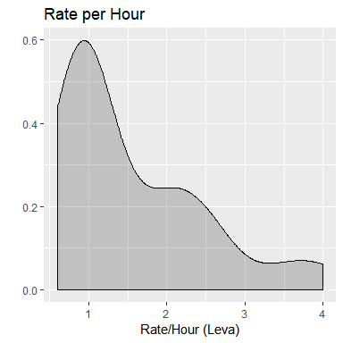
Summary Statistics:
Minimum: 0.6 leva/hour
1st quartile: 0.9 leva/hour
Median: 1.03 leva/hour
3rd quartile: 2.0 leva/hour
Maximum: 4.0 leva/hour
Mean: 1.54 leva/hour

The homeworkers that we interviewed earn between 0.6 (€0,31) and 4 BGNs (€2.05) per hour. Only one person, who takes work from 7 factories, and has specialised skills, is able to earn 4 BGN for some work. The median piece rate (if one omits outliers) per hour is BGN 1.03. This is €0.53 per hour. If one extrapolates that to 22 days per month and 8 hours per day, the average homeworker would earn BGN 8.24 (€4.21) per day and BGN 181.28 (€92.69) if they were in full time employ. Homeworkers are paid 35.55 % of the minimum wage, which is not a living wage.

Anna (not her real name) has been a homemaker for 18 years, since she was 34 years old. She makes men’s pants from her home. She works for a Bulgarian owned factory that employs 70-80 factory workers. The factory delivers pre-cut fabric and she sews the pieces together, sews the hems, irons the pants and packages them. One pair takes her 40 mins as she has learnt to work extremely fast. She is paid BGN 0.70 (€0.31) per pair of pants.

Homeworkers who had previously worked (or are still working) in factories report that factories pre-set prices for homeworkers to earn not more than 2.5 BGN (1.28 euros) per hour. One reported that “the factory takes five people and sees how many pieces they can make in an hour and then they take the average and decide on a piece rate to equal 2.5 levs and hour.” Another, who prides herself on her speed, stated that she was the “leader of the team” and because she was so fast, the factory used her as a benchmark. It calculated the piece rate for homeworkers by timing how long she took to do a task in the factory and applied this to homeworkers outside the factory. She works as a homeworker for other factories. A third homeworker, who has been working as a homeworker for over 30 years and currently takes orders from 6 -7 factories, observed that “factories form cartels” to set a ceiling on wages, but occasionally when a factory has a deadline, it offers a bit more to ‘attract homeworkers from another job’.

The average homeworker (of those interviewed) has worked as a homeworker for 11.3 years (see Figure 3). Homeworkers were asked when last they enjoyed an increase in the piece-rate. Only one had ever had an increase, and that was in 2008 before the financial crisis. Some homeworkers have worked up to 17 years without piece rates increasing. Moreover, three homeworkers reported that their piece rates have been reduced. One homeworker recounted that when she became more efficient and could earn more than BGN 2.5, “…the piece rate went down: if you are making more than 4 Levs [BGN] per hour, they cut the rate. So, working fast does not help.”

While employers provide all the raw materials, and most often equipment needed, homeworkers cover the following production: space; electricity (if they work long hours at night); and in some cases, equipment, such as a sewing machine or needles.

Homeworkers were asked whether they have asked for higher piece rates from the factories and middlemen that give them the orders. These are some of their responses:
- “I ask almost every time, but the factory refuses.”
- “The factory always says, ‘yes of course you can earn more if you do more’”
- “They say the offer is take it or leave it”
- “The boss said that if you don’t like the price you can go” [the piece rate had been the same for 8 years]
- “It is not possible to try because they have calculated it. And if you ask, they say take it or leave it”
- “The middleman says, ‘I am paid like this and I cannot pay you more’.”
- “I have never asked. There are enough people who would like to do the job”.
- “They said that if you won’t accept [the piece rate] we will find someone else.”

Several homeworkers reported that their payment is delayed by a month. The first month’s wages were only paid to them at the end of the second month. This means that the factory is always in arrears with paying their workers. Whether this is a mechanism to collect interest on wages or to manage cash flow, or whether it is a means of exercising power over the homeworker is not clear. Certainly, threat of with-holding payment is used to pressure homeworkers to work long hours to meet deadlines: “They tell us that if we don't give them the full order, we will not be paid for anything.”

- Working hours

The average number of hours worked per day is 5 and a half. Bear in mind that more than a third have other jobs, mostly in factories. And, the average homeworker works 6 days a week. More than seventy-five per cent work for more than 4.75 days a week. Average hours worked per day is approximately 5.6 hours.

Table 6: Average working hours (per day)
Minimum | 1st quartile | Median | 3rd quartile | Maximum | Mean
1.5 hrs/day | 3.0 hrs/day | 4.0 hrs/day | 6.75 hrs/day | 13.5 hrs/day | 5.59 hrs/day

The average number of days worked per week is 5.6 days. 75% of the people work for more than 4.75 days a week. See Figure 8 on the following page.

Table 7: Number of days worked per week
Minimum | 1st quartile | Median | 3rd quartile | Maximum | Mean
2.0 | 4.75 | 6.0 | 7.0 | 7.0 | 5.59

The three biggest challenges for interviewees are: low piece-rates; no contracts; and irregular work. Sixty-two per cent of interviewees complained that their work is irregular. Work is irregular for a range of reasons:
- “Sometimes there is only work for factory workers, not for homeworkers”.
- Homeworkers in the shoe sector reported that work is seasonal. They work 7 days a week between the months of October and February.
- The women who pack socks earn so little that when there is work, they work 12-15 hours a day, 7 days a week. Most of these women are on pension or disability grants.

Several homeworkers report that they take up different types of homework and seek orders from several different factories to minimize the risk of irregularity. But for those that earn the least -- such as the women packing socks --they are working such long hours and they feel as if their work is so precarious, that they don’t have the wherewithal to seek additional work.

8. Challenges and Problems faced by homeworkers

The questionnaire, which is the same questionnaire administered to homeworkers in India and Thailand, tested for a range of challenges faced by homeworkers besides low piece rates. These include: irregular work; reduction in piece rates (or withholding payment); failure to pay the total amount owed; rejection and cancellation of orders; health issues; domestic responsibilities, and “other”. Figure 7 (on the following page) illustrates interviewees’ responses. The issue of no payment because contractors disappear is not captured in these responses.

Figure 7: Challenges and Problems Faced by Homeworkers
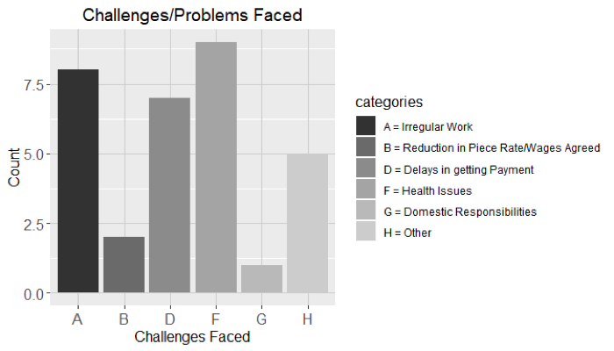

The biggest issue for homeworkers besides low piece rates is irregular work and health issues. We have discussed irregular work in the section above, and we have discussed the issues related to a reduction in piece rates and delayed payments. In this section we address “health issues” and the “other”.

Occupational health and safety
Homeworkers’ occupational health and safety concerns related to the strain on their bodies and hands as a result of excessive hours of work simply to survive. These quotes capture the desperation that people feel:
- “They put us in extremely high stress by the time frame, especially in the final part of the period they put pressure on us. They tell us that if we don't give them the full order, we will not be paid for anything”.
- “For the young person, no one will do this even for more because it is unprestigious [sic] and one is exposed to all sorts of risks (such as toxic glue) – physically you don’t feel yourself; physically homework is killing you: you do this because otherwise you will starve”.
- “I have health problems” [asthma and heart problems]] caused by working in a pants factory that “washed the pants with toxic solutions”.
- Many reported that they have to stop for an hour or so when the pain in their hands and fingers becomes extreme. We took photos of disfigured hands punctured by needles. The pain is caused by excessive hours of work: “He has debilitating pain in his hands. After 10 pairs he has to rest. Sometimes it takes 30 mins to an hour for the pain to subside”.
- Several reported extreme fatigue. One homeworker who was part of a focus group admitted that she feels pain and is exhausted, but she feels this is normal. “One just stops thinking to survive”. Other homeworkers in the focus group shared her feeling.

No written contracts
In the three-day workshop on Convention 177 in Petrich from 15-17 August 2018 that was organised by UNITY and WIEGO, the issue of contracts was raised as the single most important issue, for two reasons: First, without contracts, homeworkers cannot prove that they do work for factories. Second, without a written contract, they cannot claim any rights set out in Chapter 8 of the Labour Code, most importantly, minimum wages and social protection. In the words of one interviewee: You are dying if you become ill. If you have health problems or you get sick, you are finished [because of a lack of social protection]”.
There is almost no paperwork. During interviews, we asked about records. Homeworkers who worked inside factories (or had previously worked in factories) confirmed that factories keep records of homework. But with the exception of one instance, where a factory kept records on a computer, records are informal: handwritten, in a notebook, with only a first name; number or pieces; and piece rate. Despite a statutory obligation to keep records of homework, factories do not keep official records, which enables them to evade the other statutory requirements, as they can claim that they do not outsource to homeworkers. Homeworkers showed us slips of paper on which their first name appears, the number of orders and the price. They are not asked to sign anything and the factories’ particulars, including their names, do not appear anywhere.

Loss of Dignity/Humiliation
We were struck by the shame and humiliation experienced by homeworkers, many of whom are well educated. In the one focus group, the participants kept reassuring us that they are not earning so little because they are lazy. Key informants, interviewees, workshop participants expressed an outrage that other EU countries are either enabling, or permitting, the exploitation of both factory workers and homeworkers of a fellow EU member.

- Conclusion and Recommendations

The Bulgarian Ministry of Labour and Social Policy purportedly argues that the homeworkers are not employees, but independent contractors, because they do not have employment contracts. The following factors clearly show that these homeworkers are industrial outworkers, rather than independent subcontractors:
- None make complete products;
- All homeworkers have the raw materials (and most often also the equipment) provided to them by the factory or middleman;
- In the case of 25 out of 30 interviewees, the factory/workshop/middleman drops the raw materials and fetches the finished product;
- The factory/workshop/middleman decides on the price and the deadline for when goods should be complete; and
- Homeworkers do not have access to their customers and depend on an intermediary, which is an individual contractor, but most often a workshop or factory.

This objective of this paper is to provide a synopsis of homeworkers’ terms and conditions of work, based on ethnographic research. The literature on global value chains sheds light on the relationships between firms, and firms and labour with global value chains, it falls beyond the scope of this paper to analyse these findings in the light of broader value chain dynamics.

We conclude therefore with the viewpoints expressed by key informants. Their recommendations include the following:

First, the Labour Code must be amended to include the definition of homework that is contained in the National Agreement, that formed the basis of amendments made to the Labour Code. This definition is the following:

“Work at home is one that meets the following conditions and shall be performed:
- By an employee under and employment contract with the employer;
- By a person called and outworker in his home or in another room of his choice different than the workplace of the employer”.

Second, the Tripartite Council should establish a C177 working group that to identify the obstacles --both legal and practical - to implementation of C177. Unity must be part of such a working group, as C177 compels government to consult with “organisations concerned with homework”.
Third, homeworkers must be captured by official statistics, and if necessary the government should seek assistance from the ILO.
Fourth, the inspection mechanism must be revived to inspect factories for records, and to ensure that homeworkers have contracts, and are treated equally with employees as per C177.

Marlese von Broembsen is WIEGO’s Law Programme Director. From 2015-2017 Marlese was also a Visiting Researcher at the Institute for Global Law and Policy, Harvard Law School. Kendra is WIEGO’s Programme Support Officer.
EUROSTAT defines severe material deprivation as the inability to afford at least 4 of the following 9 items considered by most people to be desirable or even necessary to lead an adequate life: to pay their rent, mortgage or utility bills; to keep their home adequately warm; to face unexpected expenses; to eat meat or proteins regularly; to go on holiday; a television set; a washing machine; a car; a telephone.
This estimate includes both self-employed home-based workers and homeworkers.
According to EUROSTAT (2018) “The local unit is an enterprise or part thereof (e.g. a workshop, factory, warehouse, office, mine or depot) situated in a geographically identified place. At or from this place economic activity is carried out for which - save for certain exceptions - one or more persons work (even if only part-time) for one and the same enterprise.”
According to a European Union report on pension adequacy, the government of Bulgaria increased the minimum pension to 200 BNG per month in 2017. However, this figure is still less than half of the established minimum wage which was set at BGN 510 in 2018, according to EUROSTAT (2018).
Per the NACE Rev.2 classification of economic activities, the “manufacture of wearing apparel” includes all tailoring (ready-to-wear or made-to-measure), in all materials (e.g. leather, fabric, knitted and crocheted fabrics etc.), of all items of clothing (e.g. outerwear, underwear for men, women or children; work, city or casual clothing etc.) and accessories. There is no distinction made between clothing for adults and clothing for children, or between modern and traditional clothing. Overall, the number of enterprises in the manufacture of wearing apparel has declined in the last 8 years (from a total of 4,791 in 2008 to 4,428 enterprises in 2016).
Based on the Nomenclature of Territorial Units for Statistics (NUTS) regions.
Adidas defines primary suppliers (Tier 1) as, “…those factories where we hold a direct contractual sourcing relationship for the supply of products, whether for export or domestic market consumption.”
Per the NACE Rev. 2 classification of economic activities Code 15.2.
2018 data was unavailable for the following countries: Austria, Cyprus, Denmark, Estonia, Finland, Italy and Sweden.
On August 6, 2018, per the OANDA Currency Converter, 1 BGN = 0.51129EUR.

